Tableau

#Save the data in a csv file format

#Import the data to the working sheet

#Go to sheet 1

#Drag emp name and id

#Right click on the id on the left side

#a drop down box is appear

#Rename that dialogue box type

LEFT(“0000000”,(7-LEN(STR[ID] )+STR([ID])

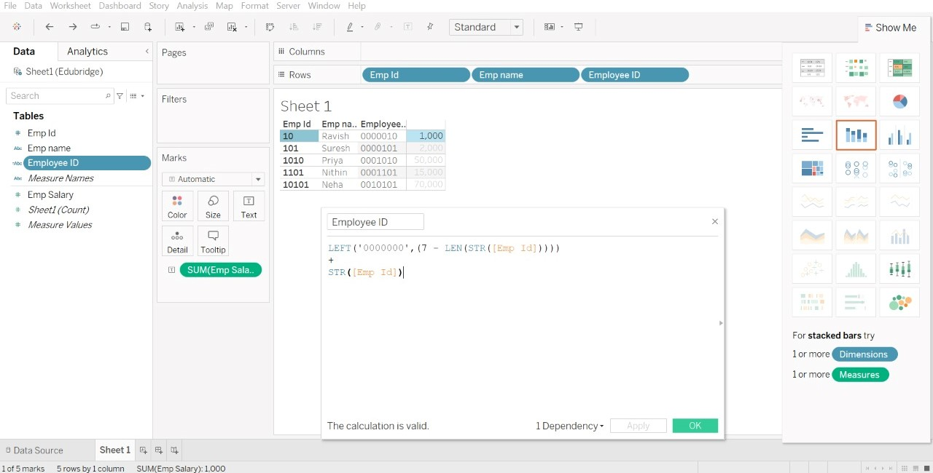

#A new column empid is created under tables ,drag and drop it into the rows